**Project Design Phase-II**

**Technology Stack (Architecture & Stack)**

|  |  |
| --- | --- |
| Date | 20 June 2025 |
| Team ID | LTVIP2025TMID28652 |
| Project Name | Educational Organisation Using ServiceNow |
| Maximum Marks | 4 Marks |

**Technical Architecture:**

For educational organizations using ServiceNow, the technology stack primarily revolves around the Now Platform, which includes various components for application development, workflow automation, and data management. The platform leverages technologies like Java, JavaScript, and its own scripting language, along with integrations to support diverse educational needs.

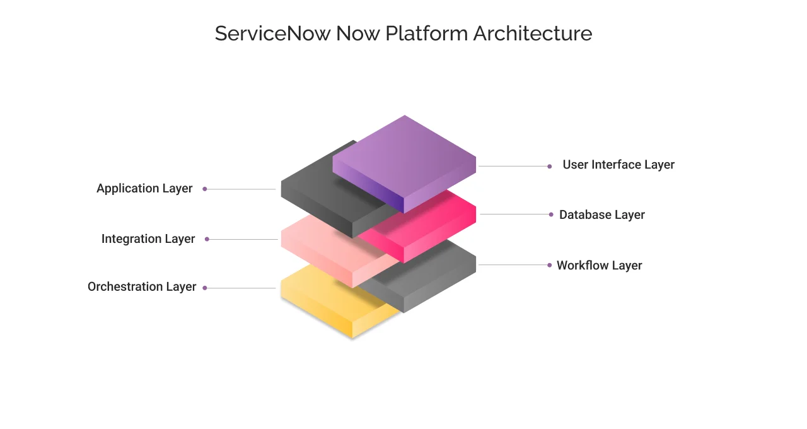

Here's a breakdown:

1. ServiceNow Platform:

• Core Technology: The ServiceNow platform is built on Java and runs on a Tomcat web server, with a shift from MySQL to MariaDB for its database, according to a ServiceNow community forum.

• Now Platform: This is the singular technology stack for all ServiceNow products and is designed to minimize digital sprawl and facilitate digital transformation within educational institutions

• Low-Code Development: ServiceNow provides low-code development tools and interfaces to automate tasks and workflows, allowing educational organizations to rapidly develop custom applications and solutions.

• Data Model: ServiceNow's platform uses a single, shared data model, which simplifies data flow across different applications and departments.

• Integration Capabilities: ServiceNow offers robust integration capabilities with other enterprise systems, enabling seamless data exchange and process automation.

2. Development Technologies:

• JavaScript: A core language for ServiceNow development, used for scripting, client-side logic, and building user interfaces

• HTML5, CSS3, and JavaScript Frameworks: Used for creating and styling user interfaces, including features like configurable workspaces and the Next Experience UI.

• Scripted Web Services: Used to create custom web service interfaces with JavaScript for defining input/output parameters, validating data, and handling complex business logic.

• Jelly: A templating language used in UI Pages and UI Macros, still supported within the Classic Environment

3. Integration Technologies:

• API Integration: ServiceNow supports various APIs (REST, SOAP) for integrating with other systems and data sources.

• Integration Hub: A feature that provides pre-built integrations and workflows for common enterprise applications and services

• Discovery: ServiceNow Discovery can identify the technology stack of applications running within the educational organization's environment, providing valuable insights for CMDB management and integration.

4. Key Features for Education:

• IT Service Management (ITSM): ServiceNow can manage IT-related tasks like incident management, problem management, and change management for the educational institution.

• Student Service Management: Enables institutions to manage student inquiries, requests, and support processes efficiently.

• Asset Management: Tracks and manages hardware and software assets used within the educational organization.

• Reporting and Analytics: Provides tools for creating reports and dashboards to analyze data and gain insights into various processes.

• Workflow Automation: Automates tasks and processes across different departments and systems, improving efficiency and reducing manual effort

• Configurable Workspaces and Next Experience UI: Provides modern, intuitive user interfaces for both students and staff, enhancing the user experience.

• Mobile Applications: ServiceNow can be used to develop mobile applications for students and faculty to access information and services on the go.

• AI and Machine Learning: Built-in AI and machine learning capabilities enable predictive analytics, personalized recommendations, and automation of tasks.

By leveraging ServiceNow's platform and its various features, educational organizations can streamline their operations, improve student and staff experiences, and drive digital transformation across the institution.